
PRODUCT SPECIFCATION SHEET
SERIES STANDARD FEATURES
- 5/16” bolted thru rod construction
- ½” insulated DSB glass (13 specialty glasses & tempered optional)
- Commercial hardware
- 10 ball bearing steel rollers
- Inside slide lock
- 2” (3” available) bracket mounted track
- Torsion spring counterbalance
- Vinyl loop bottom seal
- 5 year limited warranty
MODEL FEATURES
- 2” Thick 6063-T6 aluminum extrusions
- .050 thick solid panel bottom section
- Tongue and Grove Rails
- Clear anodized finish standard
Optional finishes available
- Sizes up to 24’-2” wide & 16’ high
- Top & bottom Rails:
up to 20’2” wide = 4-1/8”, > = 7-1/8”
- End stiles:
up to 16’-2” wide = 4’-1/8”:
- Center stiles = 2”
VENTANA COMMERCIAL SERIES
MODEL 551 INSULATED ALUMINUM GARAGE DOORS
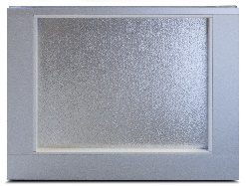
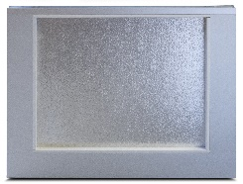
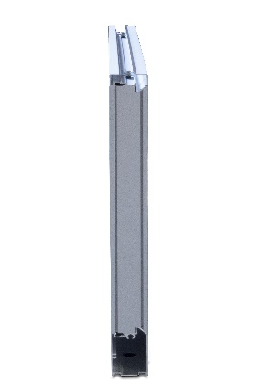

Interior View

Exterior View

AVAILABLE COLORS
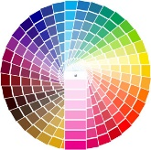

End View
Contact Your Local Dealer

Powder-coat colors to match most Safe-Way models. Consult factory for custom colors.
Aluminum Anodized

