
PRODUCT SPECIFCATION SHEET
SERIES STANDARD FEATURES
- 5/16” bolted thru rod construction
- DSB glass (13 specialty glasses optional or tempered)
- Commercial hardware
- 10 ball bearing steel rollers
- Inside slide lock
- 2” (3” available) bracket mounted track
- Torsion spring counterbalance
- Vinyl loop bottom seal
- 5 year limited warranty
MODEL FEATURES
- 2” Thick 6063-T6 aluminum extrusions
- .050 thick solid panel bottom section
- Tongue and Grove Rails
- Clear anodized finish standard
Optional finishes available
- Sizes up to 14’-2” wide & 14’ high
- 3” – Top, bottom & end stiles
1-7/8” center stiles
VENTANA COMMERCIAL SERIES
MODEL 450 ALUMINUM GARAGE DOORS
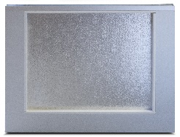
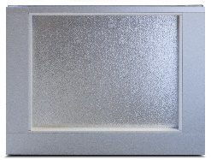
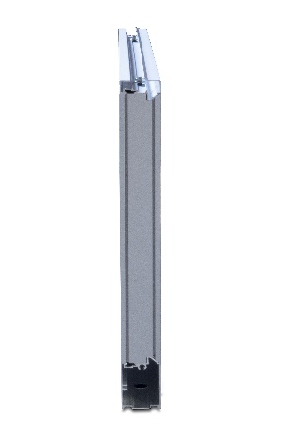

Exterior View

Interior View

AVAILABLE COLORS

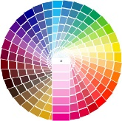

End View

Contact Your Local Dealer
Aluminum Anodized
Powder-coat colors to match most Safe-Way models. Consult factory for custom colors.

