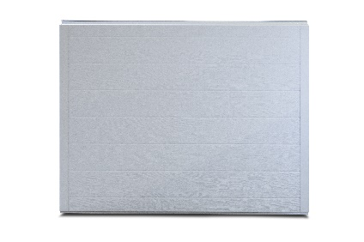

PRODUCT SPECIFCATION SHEET
SERIES STANDARD FEATURES
- Heavy Duty construction
- 2” Expanded polystyrene foam core with R-value = 10.25
- Pencil grooved panel design
- 20 gauge painted end stiles
- Continuous vertical backer
- Commercial hardware
- Bracket mounted track
- 10 ball steel rollers
- 2” track (3” track available)
- Torsion spring counterbalance
- Aluminum & vinyl loop weather seal
- Limited lifetime warranty
MODEL FEATURES
- 27 gauge steel interior & exterior skins
- Woodgrain embossed texture
- 2” Thick Sections
- Tongue & Groove meeting joints
- Sizes up to 20’ wide & 16’ high
- White interior
MADERA REGENCY RESIDENTIAL SERIES
MODEL 271 STEEL INSULATED GARAGE DOORS
AVAILABLE COLORS

Exterior View

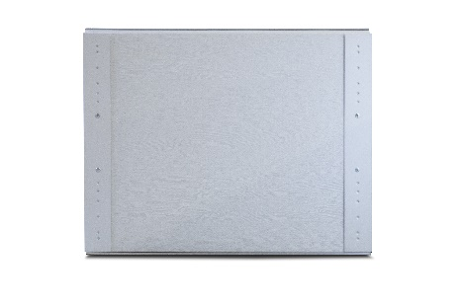
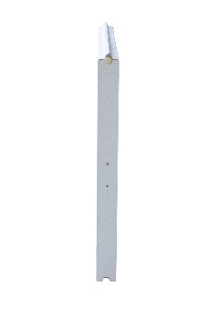

Interior View

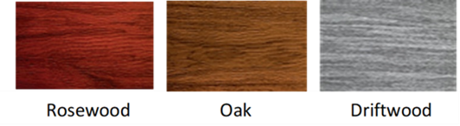
End View
Contact Your Local Dealer

