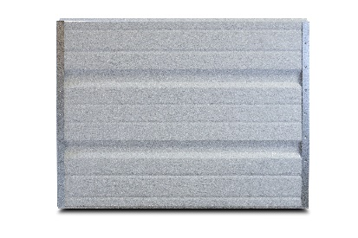

PRODUCT SPECIFCATION SHEET
SERIES STANDARD FEATURES
- Heavy Duty construction
- 1-3/8” expanded polystyrene with vinyl backer and R-value = 6
- Tog-L-Loc fastening construction
- Deep ribbed panel design
- 20 gauge galvanized end stiles
- Commercial hardware
- 10 ball steel rollers
- 2” or 3” bracket mounted track
- Torsion spring counterbalance
- Inside slide bolt locks
- Aluminum & vinyl loop weather seal
- 10 year limited warranty
MODEL FEATURES
- 25 gauge steel skin
- Embossed wood grain texture
- 2” Thick Sections
- Tongue & Groove meeting joints
- Sizes up to 18’-2” wide & 14’ high
- White Interior
COMMERCIAL SERIES
MODEL 261 DEEP RIBBED STEEL GARAGE DOORS
AVAILABLE COLORS
Interior View

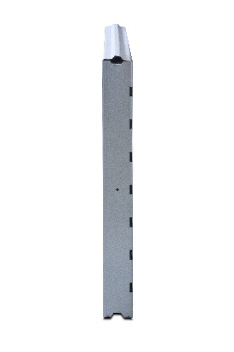
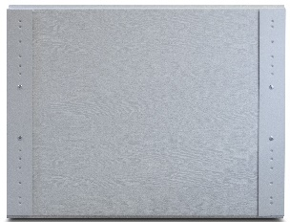

End View

Contact Your Local Dealer

White

